Graph 1: Showing Comparisons of Percentages of filled TRF details
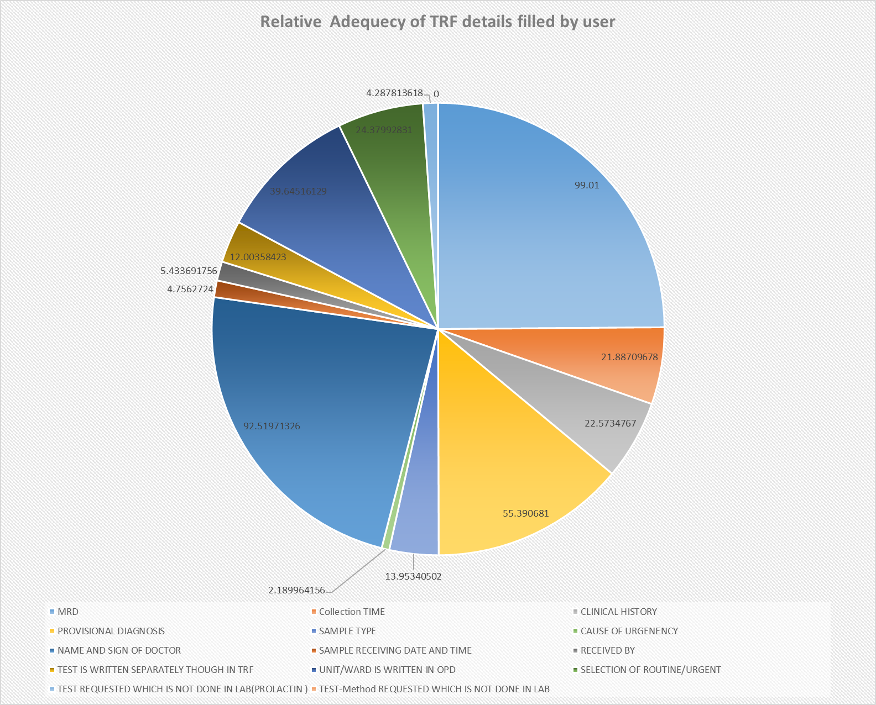

Graph 2: Bar Chart showing % of TRFs with Filled various Details
